# ***Instructions:*** *At the highest of levels Quality Management involves planning, doing, checking, and acting to improve project quality standards. PMI PMBOK breaks the practice of Quality Management into three process groups: Quality Planning (QP), Quality Assurance (QA) and Quality Control (QC). The following sections define how this project will apply to each of these practice groups to define, monitor and control quality standards.*

**Quality Roles & Responsibilities**

|  |  |
| --- | --- |
| **Role** | **Responsibilities** |
| **1.** | **1.** |
| **2.** | **2.** |
| **3.** | **3.** |
| **4.** | **4.** |

# **Quality Planning:**

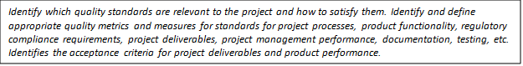

# **Define Project Quality:**

Text Box

**Measure Project Quality:**

Text Box

**QUALITY ASSURANCE**:

Text Box

**Analyze Project Quality:**

Text Box

**Improve Project Quality:**

Text Box

**QUALITY CONTROL:**Text Box