***Instructions:*** *This worksheet will assist in defining the organization’s culture and history, and help you complete a* ***Cultural Assessment*** *that will be a guide for developing your change management strategies and actions. This worksheet can be completed as a group exercise or individually.*

**Organizational Culture**

Is the organization change-ready or change resistant?



**Employee Culture**

Do employees accept changes mandated from the leadership team or is there resistance to changes from the top? Why?

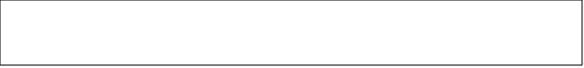

Describe the current policies or procedures that reinforce this value system:



**Organization’s Capacity for Change**

What changes are currently being implemented at your organization?



Is there capacity for more change?



Are there any change initiatives that will conflict or overlap with your change?



**Leadership Culture**

Where does the power and authority reside in your organization?



Where does the true power reside?



**Previous Change Culture**

How successful were previous changes?



Are employees open to change or skeptical of change? Why?



What lessons did you learn from previous changes?



What do you think caused these previous changes to fail or succeed?



**Culture of Mid-Managers**

What challenges will mid-level managers and supervisors have?



Identify “The Lovers,” “The Haters” and “The Just Don’t Cares”

