***Instructions:*** *Aids in the definition of the organizational change through defining the who, what, where, when, why and how of the change initiative.*

What will be changing (briefly describe the change)?

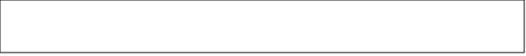

Who will be impacted by the change?

Text Box

When will the change happen?

Text Box

Where in the organization will the change take place?

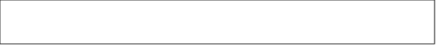

Why will the change happen?

Text Box

How will the change be implemented?

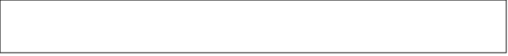

What are the business outcomes you hope to achieve when the change is complete?

