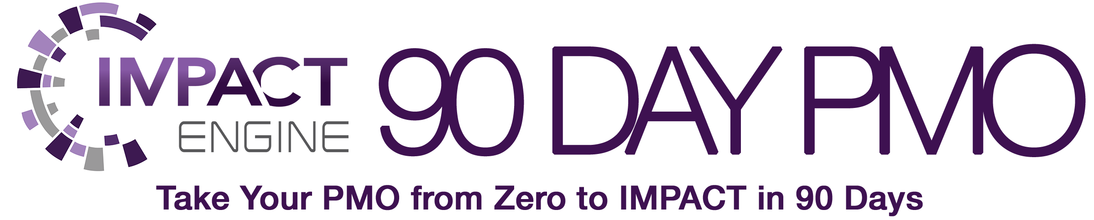

|  |
| --- |
| **PMO Business Case** |

by



PMOStrategies.com

**PMO Business Case**

|  |
| --- |
| Now that you’ve done the work to determine the PMO Focus, evaluate all the various inputs that will influence the outcomes and direction of the PMO, you can now build your PMO business case. This PMO business case will help you articulate the objectives and scope of your PMO, as well as help you develop the components necessary to drive a strong PMO proposal. The PMO proposal takes the inputs from the recommendation process and digs deeper into all aspects of the PMO IMPACT model.  Complete this business case to clearly articulate your mechanisms for driving IMPACT and support you will need to Get. It. Done. with your IMPACT Engine™ PMO. |

**IMPACT Engine™ PMO Business Case**

**Introduction and Purpose**

The purpose of this document is to outline the business case for the PMO and establish the objectives, scope, focus, and IMPACT the PMO will have on the organization.

**Executive Summary**

*Provide a very brief summary of what is included in the business case and what you intend for the reader to take away or do as a result of reading this business case. All your deliverables should have a clear purpose and outcome expected. They should drive action and decisions.*

**Historical Context**

*Provide any historical information or background that is valuable to the purpose of your PMO or direction. This is not a place to provide a laundry list of complaints or point fingers, rather focus on the opportunities identified for growth.*

**Business Need**

*Provide a summary of the inputs obtained in the Assessment process, the information determined during your SWOT analysis, and the assessment outcomes. Make sure to explain in terms defined by your survey and input process, using the language that your business stakeholders are using to explain needs.*

**Scope**

*Define the scope for the PMO in high-level terms. This was determined when you established your PMO Direction during your PMO Assessment work.*

**IMPACT Analysis**

*Explain the various components of IMPACT identified and added to your PMO Focus, divided by stakeholder group you intend to serve and what positive IMPACTS they will experience by the services delivery.*

**PMO Vision**

*Create your aspirational description of how the PMO will drive IMPACT for the organization. Choose words carefully that describe the essence of the value you want to create with the PMO. This allows you to manage expectations and help lead the PMO stakeholders through the transformation process.*

**PMO Mission**

*Develop a mission statement that encompasses the high-level PMO Focus, while also adding some data points to help indicate how you will know if you are achieving that mission.*

**Strategic Objectives**

*Define the high-level objectives for the PMO. This was determined when you collected the feedback on the PMO Focus, collected your assessment feedback to determine the high-IMPACT areas of opportunity and strength, and evaluated all other survey input collected during your PMO Assessment work. Whether this data came from the initial assessment or a new assessment as a part of the Evolve and Sustain processes, now is the time to update the Strategic Objectives to ensure any new areas of focus are explained. Take all those inputs and use that to determine the PMO Direction and Strategic Objectives.*

**PMO Guiding Principles**

*Indicate the guiding practices and framework you will use to measure and affirm your PMO Services and delivery model.*

**PMO Roles and Responsibilities**

*Define the PMO roles and responsibilities for the key players in your PMO and other stakeholders that are contributing to the build out process.*

**Critical Success Factors**

*Explain what criteria will be used to measure success of the PMO and how you will know your PMO is on target with intended outcomes and IMPACT.*

**Assumptions**

*Indicate the assumptions you are making when defining the content of the business case.*

**Obstacles**

*Document the outcomes of the SWOT analysis that will indicate both the weaknesses and the threats that could impede progress and what you recommend happen to minimize the likelihood or severity. Make sure to include the inputs from the PMO Risk Register, as appropriate.*

**Stakeholder Engagement Strategy**

*Establish your strategy for engaging stakeholders throughout the PMO build and delivery process.*

**Budget and Intentions to Create ROI**

*Provide information on both your expenses and the way you intend to contribute or support revenue for the organization.*